ابسم الله الرحمن الرحيم
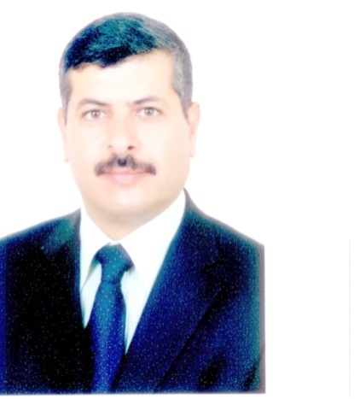
الاســــــــــــــــــــم: محمد فالح مصطفى الحناقطة الحميدات.
الجنـــــــــســــــية:أردني
تاريخ المــــــــيلاد :27-3-1965 .
مــــــكان الولادة : الطــــفــــــيلة.
العنـــــــــوان: الاردن / الزرقاء - مدينة الشرق / تلفون 0779771014
المؤهلات العلمية .
دكتوراه في الترجمة من جامعة ( يو اس ام) ماليزيا 2015.
ماجستير ترجمة من جامعة سالفورد في بريطانيا 2010.
خريج جامعة ساندهيرتس الملكية البريطانية عام 1987.
دورة لغة انجليزية في معهد بيكونسفيلد في بريطانيا لمدة (5) شهور.
دورة لغة انجليزية في أمريكا لمدة (4) شهور.
دورة لغة فرنسية في المعهد الفرنسي بعمان لمدة (6) شهور.
دورة توفل من جامعة ال البيت.
شهادة الكومبيوتر الدولية من جامعة العين في دولة الامارات العربية.ICDL

الخبرات السابقة.
1. العمل في وزارة الدفاع الاردنية لمدة 16 عام منذ عام 1985 ولغاية 2002 في مجال الترجمة والتدريس والتدريب.
2. العمل كمترجم وضابط ارتباط لمدة عام مع الأمم المتحدة في يوغسلافيا عام 1995.
3. العمل كرئيس للمترجمين في كلية زايد في دولة الإمارات العربية منذ 2005 -2009
4. العمل كمترجم مع شركة نوليج بوينت في ابو ظبي لمدة سنة ونصف.
5. استاذ مساعد لتخصص الترجمة في جامعة الشرق الاوسط من 2016- 2017.
6. محاضر متفرغ لتخصص الترجمة في الجامعة الاردنية 2017 -2018.

C.V
Personal information
Name: Muhammad Faleh Al-Hanaqtah.
Nationality: Jordanian.
Date of birth: 27/3/1965.
Place of birth.Tafilah.
Address: Jordan /Zarka City
TEL. 0779771014(Jordan).
Email:m-hanaqtah@hotmail.com
Certifications and Courses:
1. PhD. Degree in translation from USM University Malaysia(2015).
2. Masters Degree in translation from Salford University in England (2010).
3. Graduated from the Royal Academy Sandhurts in England(1987).
5. English language course in Beaconsfield-England (5 months).
6. English language course -USA , Kentucky (4 months).
7. French language course in Jordan (6 months).
8. Toefl course In Al –Albayt University.
9. ICDL course from AL- Emirate University in AL-Ain.
Experience:

1. Working with the Jordanian Ministry of defense from 1985 up to 2002 as a translator and instructor.I was involved in teaching and training the ministry staff in English how to develop their experience, skills, and the knowledge they need to elevate the stander of their performance in addition to the followings:

A.Oversee the sourcing, interviewing, hiring, training, and set-up of new translators.

B. Equipping individuals and teams with the relevant support and skillsnecessary to effectively perform their roles.

C. Conduct translation performance evaluations and reviews.

2. Translator for one year with the UN in former Yugoslavia 1995.

3. Chief translator in Zayed Military College in the UAE.I was holding the position of chief translator of a team of 16 translators supporting the staff at Zayed Military Academy in the United Arab Emirates. My work involved both verbal and written translation of various documents from Arabic into English and vice versa.

4. Working as a translatorwith Knowledge Point Company (KP) in Abu Dhabi for one and a half year.

5. Assistant Professor For Translation and Interpretation Studies at The Middle East University in Jordan 2016-2017.

6. Assistant Professor For Translation and Interpretation Studies at the University of Jordan 2017 -2018.

Conferences:

1. The Art of Writing Publishable Scientific Manuscripts dated on 10/6/2013.

2. Publishing research articles in high-impact journals :strategy and steps dated on 9/9/2013.

3. Preparation for Viva Voce Examination dated on 11/9/2013.

4. Qualitative Data Analysis dated on 23/9/2013.

5. Nvivo 10-qualitative data analysis dated on 28/10/2013.

6.Thesis Writing for Beginners dated on 6/6/2013.

7.Introduction to Research Methodology dated on 10/7/2013.

Publications:

1. Paper titled "Difficulties that Encounter Arab Students during the process of conducting Simultaneous and Consecutive Interpretation” at JIARM (JOURNAL OF INTERNATIONAL ACADEMIC RESEARCH FOR MULTIDISCIPLINARY),dated on January 27, 2017.

2. Paper titled "Translating Military Slang Terms from English into formal Arabic" at Journal of Research on Humanities and Social Sciences”. Dated on December 21, 2016.

Masters Supervision

1. Supersizing an MA thesis carrying the title ‘Difficulties Encountering MA students translating Newspaper Headlines from English into Arabic’. Submitted by the student Thanaa Hindi Salih Al falahy(2017).

2. Supersizing an MA thesis carrying the title ‘Difficulties that face Ba students when translating prepositions of movements from English into formal Arabic’.

Submitted by the student Nadia Lutfi Dawoud (2017)
3. Supersizing an MA thesis carrying the title “Difficulties and problems that encounter BA students at private universities when translating lexical legal terms” Submitted by the student Maysoon Issa Elsadik (2018)

